**The Difference in Early Alcohol Consumption Between Women and Men**

Angelo Saravia

UC Davis

Department of Psychology

**Introduction**

The purpose of this study is to confirm if there is a relationship between the age someone has consumed their first alcoholic beverage and their gender. Given the extensive evidence for a greater probability in alcoholism within males (National Institute of Health, 2006), the hypothesis for this study is that the mean age for a first alcoholic beverage consumption will be lower for males than for females. This analysis could benefit alcohol prevention by providing a statistic specific to gender. Having hypothesized that , on average, males have their first drink at an earlier age, we can provide evidence for a need to redirect alcohol prevention measures with an emphasis on males. Furthermore, the statistics provide insight into the average female drinking ages, giving future researchers access to mean drinking ages for females for further study. In future, this study can provide prevention against cognitive decline, reckless sexual activity, and general physical health.

**The Procedure**

The original sample of MIDUS participants was made up of a nationally (U.S.) representative sample of non-institutionalized English-speaking adults, aged 25-74 (NACDA, 2006). The follow up for MIDUS, MIDUS 2, is where the data for this study is collected from. MIDUS 2 is a longitudinal follow-up to the original MIDUS sample. All respondents (N = 3,487) were aged 35 to 86. Questionnaire samples were taken via phone interviews and self-administered questionnaires. An African American sample (N = 592) was also recruited from Milwaukee, Wisconsin.

**Participants**

Midus : B1PA49 : This variable accounts for the age that all participants had reported for drinking their first alcoholic beverage. The question asked was: "How old were you when you had your first drink, not counting a sip of someone else's drink? (NACDA, 2006). For (N = 690) participants, an age was provided. The second variable was a categorical variable with two levels accounting for the gender provided by (N = 690) participants: male or female (NADCA, 2006).

**The Data Analysis**

Because I am examining one sample with two levels and do not know the population's true standard deviation, I performed an independent sample’s t-test. The mean age of participants' first alcoholic beverage for both men and women was, mean = 27.95652. The mean age of a first alcoholic beverage consumption for males was, mean = 24.80645. As hypothesized, the average age for women was much higher, mean = 30.52632. Given that the sample size of my dependent variable was sufficiently large (n = 690 > 30), normality in the distribution was assumed. Although the sample size is sufficiently large, after running tests for normality, it is clear that the true populations from which our samples come from are not normally distributed. Prescribing an alpha = .05, the one-sample t-test provided a p-value (p = 0.003796) that was low enough to refute the null hypothesis. Moreover, the Shapiro-Wilk test of normality provided a W = .5. While the sample quantities are not ideally standardized, the significantly low p-value (2.2e-16) confirms our rejection of the null hypothesis. With a p-value that is < than .05, I rejected the null hypothesis.

**Methods**

By the discrete nature of the gender category, I assumed that both of the categorical levels in the study (i.e. males and females) are independent. This assumption carries over to the independent t-test run for our hypothesis test. To test for the assumption of equal variances between the two levels, I ran a Breush-Pagan test which confirmed that the two samples’ variances were equal (BP = 3.5877, df = 1, p-value = 0.05821). The null hypothesis for the normality for both groups was that each sample did not originate from a normally distributed population. The alternative hypothesis was that they did. I used the Shapiro Wilk’s test for normality with an alpha value = 0.05. to confirm that the samples had originated from a normally distributed population. For the male category, I accepted the null hypothesis, given the test results (W = 0.47996, p-value < 2.2e-16). The null hypothesis for normality for the female category was also accepted, given the test results (W = 0.55571, p-value < 2.2e-16). Refer to the appendix for the associated qq-plots which also confirmed non-normality in Figure A1, pg. 7. I ran three data transformations to correct for both samples not being normally distributed. Using square-root (Figure A2, pg. 8), logarithmic (Figure A3, pg. 8), and reciprocal transformations (Figure A4, pg. 9) provided no significant change toward achieving normalcy (refer to appendix A). After running the Breush Pagan test, I could assume that both groups had equal variances, and so a Welch’s t-test was unnecessary. Instead, a student’s independent two sample t-test was run. With a p-value < .001 (p < alpha = .05).

**Results**

The male and female categories had distinct means: for the male category, its mean = 24.80645 (sd = 23.77173) was clearly lower than the female categories’ (mean = 30.52632, sd = 27.94636). With the mean difference between both groups equal to 5.71987, the two samples t-test was run to confirm this significant mean difference. Given the selected p-value for alpha was equal to .05 and a outputted t-test p-value < .001, I rejected the null hypothesis and concluded that there was a true difference of means between the female and male first drinking ages (t = -2.8576, df = 688, p-value = 0.004398). The degrees of freedom I used for this study was equal to 688. With the rejection of the null hypothesis based on the t-test, I assume this is evidence which suggests a significant difference with first-drink ages between males and females.

**Discussion**

Given that I was unable to achieve normalcy through data transformations, this study has a severe limitation and may be improved upon by alternative statistical methods. However, the difference of means ( = 5.71987) and the p-value for the t-test being < .001, both provide sufficient evidence for a further need to continue research involving the differences among drinking habits within gender categories. Further research can build off of these results by updating the gender categories and also by excluding participants with ages exceeding 80 years of age. As this study stands, its results suggest that males are more likely to consume an alcoholic beverage at a younger age than females. This evidence may encourage future researchers to infer on the sociological and/or biological influences that may contribute to early drinking ages for males.

**References**

Ceylan-Isik, A. F., McBride, S. M., &amp; Ren, J. (2010, July 31). Sex difference in alcoholism: Who is at a greater risk for development of alcoholic complication? Life sciences. Retrieved March 15, 2022, from <https://www.ncbi.nlm.nih.gov/pmc/articles/PMC2913110/>

Ryff, C. D., Almeida, D. M., Ayanian, J. Z., Carr, D. S., Cleary, P. D., Coe, C., Davidson, R. J., Krueger, R. F., Lachman, M. E., Marks, N. F., Mroczek, D. K., Seeman, T. E., Seltzer, M. M., Singer, B. H., Sloan, R. P., Tun, P. A., Weinstein, M., & Williams, D. R. (2021, September 15). Midlife in the United States (MIDUS 2), 2004-2006. Retrieved March 15, 2022, from https://www.icpsr.umich.edu/web/NACDA/studies/4652?paging.startRow=1&keyword=relationships&recency=QUARTER

**Appendix A**

**Figure A1.**

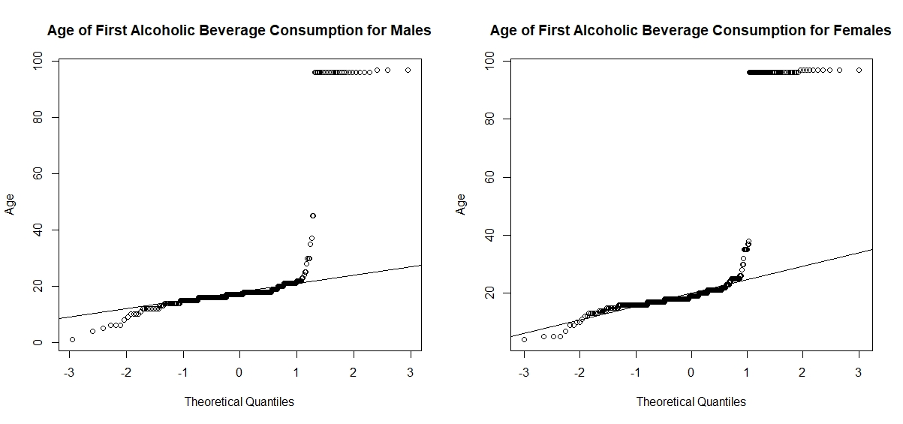

**Figure A2.**

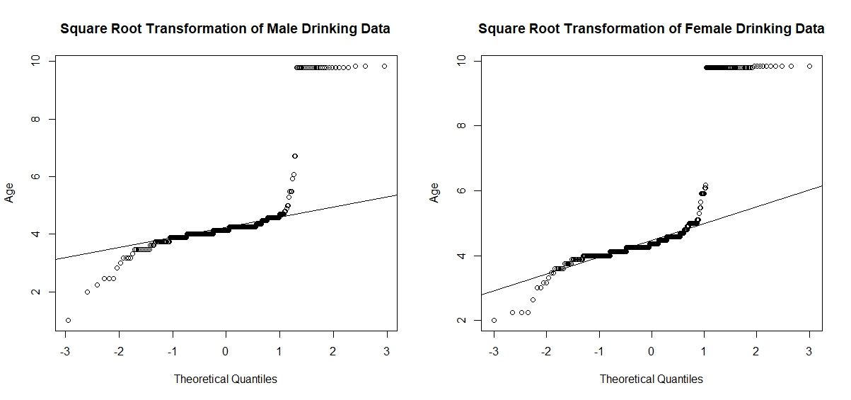

**Figure A3.**

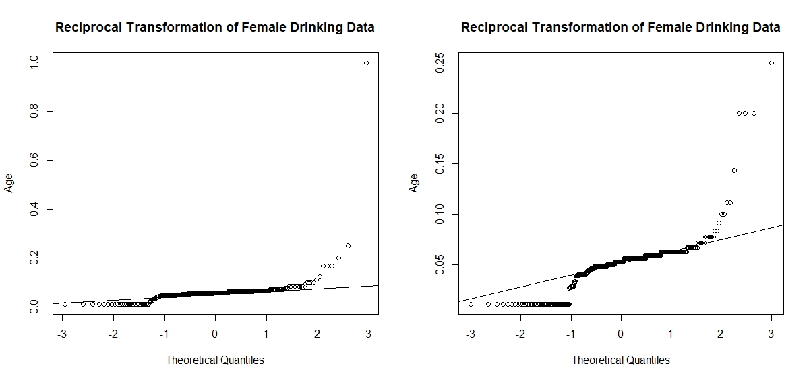

**Figure A4.**

